**Question 1 Part A**

Compare and contrast the following two designs

* Completely Randomised Design
* Randomised Complete Block Design

**Question 1 Part B**

Four areas in a lake are sampled and the chemical oxygen demand measured. The results are shown below.

Complete the following ***One-Way Analysis of Variance*** Table using the following pieces of additional information.

* The Total Sum of Square is 1125.75.
* The Mean Square Error is 20.75

|  |  |  |  |  |  |
| --- | --- | --- | --- | --- | --- |
|  | Df | Sum Sq | Mean Square | F | P-value |
| Group |  |  |  |  | 0.0001641 |
| Residual |  |  | 20.75 |  |  |
| Total |  | 1125.75 |  |  |  |

State your conclusions about the outcome of this inference procedure, stating clearly the null and alternative hypothesis.

**Question 2 Part 1**

Assume that we have three fertilizers to be tested. We wish to determine if there is any difference is the mean yields for the three different types of fertilizer.

|  |  |  |  |  |
| --- | --- | --- | --- | --- |
| Fertilizer | Yields | | | |
| A | 5.6 | 6.4 | 6.6 | 5.8 |
| B | 5.1 | 6.2 | 6.4 | 5.7 |
| C | 5.0 | 6.1 | 5.8 | 5.5 |

The following ***R*** output is a ***One Way ANOVA*** procedure for testing multiple means.

|  |
| --- |
| > ModelA=aov(Yield~Fert,Study1)  >  > summary(ModelA)  Df Sum Sq Mean Sq F value Pr(>F)  Fert 2 0.50 0.2500 0.957 0.42  Residuals 9 2.35 0.2611 |

For this procedure, state the null and alternative hypothesis, and your conclusion.

**Question 2 Part 2**

Assume that we have three fertilizers to be tested, the decision is made to use four blocks,

and the data below contain a measure of crop growth for each combination of block and

fertilizer when the experiment is conducted.

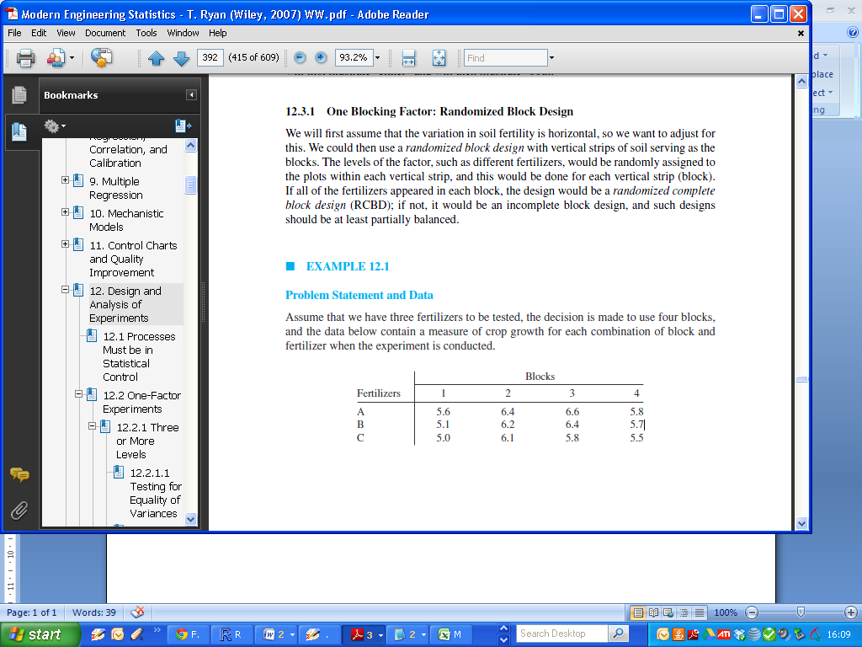

The following ***R*** output is a ***Two Way ANOVA*** procedure for analysing this data

|  |
| --- |
| > summary(Model2)  Df Sum Sq Mean Sq F value Pr(>F)  Fert 2 0.5000 0.2500 10.23 0.011667 *  Block 3 2.2033 0.7344 30.05 0.000519 ***  Residuals 6 0.1467 0.0244 |

Describe how this output would revise our conclusion on the performance of the fertilizers.

**Question 3**

Samples from five different suspensions of bacteria A,B,C,D,E, were examined under a microscope by four different observers I,II,II,IV; the order in which each observer dealt with the samples was randomized to reduce errors due to fatigue, and the number of organisms recorded from the samples are summarized below.

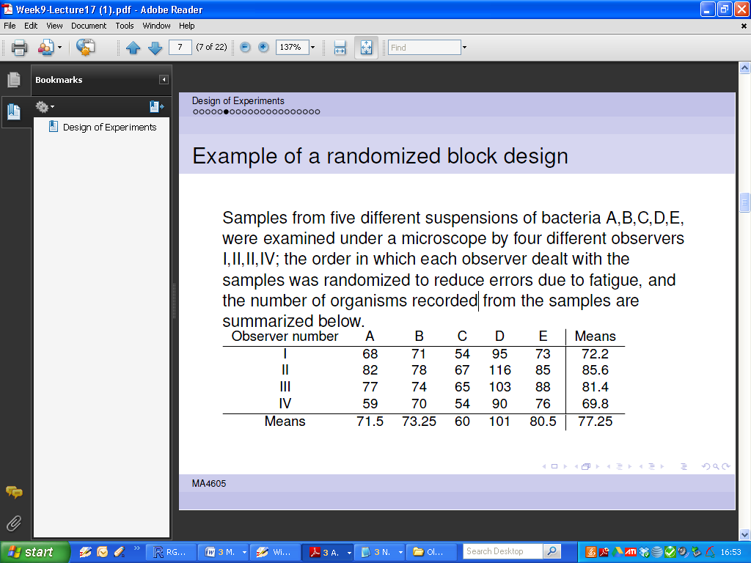

|  |
| --- |
| > summary(ModelA)  Df Sum Sq Mean Sq F value Pr(>F)  Obs 3 840 279.9 17.40 0.000114 ***  bact 4 3685 921.3 57.28 1.02e-07 ***  Residuals 12 193 16.1  ---  Signif. codes: 0 ‘***’ 0.001 ‘**’ 0.01 ‘*’ 0.05 ‘.’ 0.1 ‘ ’ 1 |

Q1: For this data set – describe what would correspond to the ***treatment***, and what would correspond to the ***block***?

Q2: are the differences between treatment means significant?

Q3: are the differences between block means significant?

**Question 4**

Describe what an Interaction Effect is.

Consider the following model summary. Is there a significant interaction effect present?

|  |
| --- |
| > ModelB = aov( len ~ dose + supp + dose:supp ,ToothGrowth)  > summary(ModelB)  Df Sum Sq Mean Sq F value Pr(>F)  dose 1 2224.3 2224.3 133.415 < 2e-16 ***  supp 1 205.3 205.3 12.317 0.000894 ***  dose:supp 1 88.9 88.9 5.333 0.024631 *  Residuals 56 933.6 16.7  --- |

